**JSS MAHAVIDYAPEETHA**

**JSS Science and Technology University**



**“Automotive Sensor-Based Driver Performance Analysis”**

A technical project report submitted in partial fulfillment of the award of the degree of

BACHELOR OF ENGINEERING

IN

COMPUTER SCIENCE & ENGINEERING

**BY**

Prashasti Mattas 01JST20CS119

Akhil Rasheed 01JST20CS014

Prithviraj B 01JST20CS120

Aditya Soundara Rajan 01JST20CS009

Under the Guidance of   
**Dr. Prasanna B T**

Associate Professor

Department of Computer Science & Engineering

JSS STU Mysore

**2023-24**

**DEPARTMENT OF COMPUTER SCIENCE & ENGINEERING**

**JSS MAHAVIDYAPEETHA**

**JSS Science and Technology University**



**CERTIFICATE**

This is to certify that the work entitled “ **Automotive Sensor-Based Driver Performance Analysis**” is a Bonafide work carried out by Aditya Soundara Rajan (01JST20CS009), Akhil Rasheed (01JST20CS014), Prashasti Mattas (01JST20CS119) and Prithviraj B (01JST20CS120) in partial fulfilment of the award of the degree of Bachelor of Engineering in Computer Science and Engineering for the award of Bachelor of Engineering by JSS Science and Technology University, Mysuru, during the year 2023-2024. The project report has been approved as it satisfies the academic requirements in respect to project work prescribed for the Bachelor of Engineering degree in Computer Science and Engineering.

## 

## **Under the guidance ofHead of the department**

**Dr. Prasanna B T Dr. Srinath S.**

Associate Professor Assoc. Prof. and HOD

Dept. of CS &E Dept. of CS &E

JSS STU Mysore - 06 JSS STU Mysore - 06   
Name of Examiner Signature with Date

1. ......................................... .........................................

2. ......................................... .........................................

**Certificate of Plagiarism Check**

**DECLARATION**

We do hereby declare that the project titled **“Automotive Sensor-Based Driver Performance Analysis”** is carried out by **Aditya Soundara Rajan (01JST20CS009), Akhil Rasheed (01JST20CS014), Prashasti Mattas (01JST20CS119) and Prithviraj B (01JST20CS120),** under the guidance of **Dr. Prasanna B T**, Associate Professor, Department of Computer Science and Engineering, JSS Science and Technology University, Mysuru, in partial fulfilment of the requirement for the award of Bachelor of Engineering by JSS Science and Technology University, Mysore, during the year 2023-2024.

We also declare that we have not submitted this dissertation to any other university for the award of any degree or diploma courses.

**Date:**

**Place: Mysore**

Prashasti Mattas 01JST20CS119 Akhil Rasheed 01JST20CS014  
Prithviraj B 01JST20CS120  
Aditya Soundara Rajan 01JST20CS009

**ACKNOWLEDGEMENT**

**ABSTRACT**

This research project addresses the critical challenge of effectively profiling driver behavior by leveraging smartphone sensors and machine learning algorithms. Recognizing the profound impact of driver conduct on various facets such as traffic safety, fuel consumption, and emissions, our study underscores the need for economical solutions. We utilize diverse Android smartphone sensors, including accelerometers, gyroscopes, and GPS, to automatically collect and analyze driving data. The primary objective is to identify optimal combinations of sensors and machine learning methods that demonstrate superior performance in characterizing driver aggressiveness.

Our central focus lies in finding a balance between cost-effectiveness and high performance in the realm of driver behavior profiling. Through extensive experimentation, we showcase that specific sensor-algorithm assemblies lead to improved classification outcomes. These findings offer valuable insights for developing practical and efficient approaches to driver behavior profiling. By presenting a cost-effective methodology that harnesses readily available smartphone sensors and advanced machine learning techniques, our research aims to pave the way for impactful interventions that positively influence driver behavior, thereby contributing to enhanced road safety and sustainability.

TABLE OF CONTENTS  Page No.

List of figures i

List of tables ii

Chapter 1: Introduction

1.1. Problem Statement

1.2. Aim and Objectives

1.3. Applications

1.4. Existing Solution

1.5. Proposed Solution

1.6. Gantt Chart

Chapter 2: Literature Review with gap in the literature

Chapter 3: System Requirements and Analysis

Chapter 4: Tools and Technology Used

Chapter 5: System Design

Chapter 6:System Implementation

Chapter 7: System Testing and Result Analysis

Chapter 8: Conclusion and Future Work

APPENDIX A - Project team details

APPENDIX B - COs, POs and PSOs mapping for the project work (20CS83P)

APPENDIX C – Publication details

REFERENCES

**List of Figures:**

Fig 1.1.1: Trends in the number of persons killed in road accidents

Fig 1.4.1: Working of the SenseFleet system

Fig 1.4.2: Safe Drive System Methodology

Fig 1.4.3: Implementation technique

Fig 1.6.1: Timeline of the project

Fig 1.6.2: Flowchart of the project implementation

Fig 5.1: Proposed System Design

Fig 5.2: Proposed Flutter App Flow

Fig 5.3: Proposed Implementation Methodology

Fig 6.1.1: Trip Summary Page  
Fig 6.1.2: Trip Page   
Fig 6.1.3: Login Page  
Fig 6.1.4: Register Page  
Fig 6.1.5: Dashboard   
Fig 6.3.1: Distribution of events per driver  
Fig 6.3.2: Types of events  
Fig 6.6.1: Heatmap for the events   
Fig 7.1: LOF Model Graph Representation   
Fig 7.2: Multivariate Analysis: correlation matrix of the original features and the first principal component  
Fig 7.3: Metric and percentile calculated

**List of tables**

Table 6.2.1: Pointer Telelocation Dataset

Table 6.4.1: Refined Data

Table 6.5.1: Normalized Behavioral Event Features

Table 7.1: Top 10 safest drivers based on the metric

Table 7.2: Top 10 most risky drivers based on the metric

**Chapter 1: Introduction**

**1.1 Problem Statement**

One of the most populous countries in the world, India, has seen an alarming increase in accident rates, which are mostly the result of careless driving. The nation saw more than 150,000 traffic fatalities a year due to its varied and difficult road infrastructure according to September 2021 data [1]. These statistics highlight the critical need for creative solutions to improve traffic safety and lower accident rates, which makes a thorough evaluation of driver performance essential.

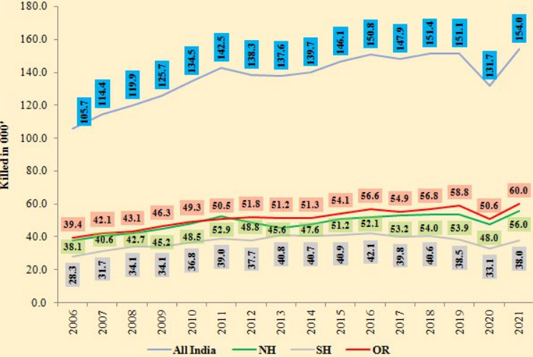

*Fig 1.1.1: Trends in the number of persons killed in road accidents[**1**]*

Using the capabilities of in-vehicle sensors[2-3] is a crucial way to address this problem and increase road safety. These sensors provide the ability to gather and examine information on the state of the roads as well as the actions of drivers. A technique to utilize in-vehicle sensors is explored in this study.

Driver performance analysis: this study delves into driver performance analysis, where sensors monitor aspects like acceleration, braking, steering, and even physiological data. This comprehensive evaluation of a driver’s performance can provide valuable insights into their behavior behind the wheel, promoting safer driving practices.

This project delves deeper into these aspects and their potential to revolutionize road safety in

India.

**1.2 Aim and Objectives**

1. **To address the high accident rates in India:**

**Aim**: to reduce the alarming increase of road accidents in India, especially due to irresponsible driving behaviour..

**Objective**:

* + 1. Emphasize the need for innovative approaches to investigate the contributing factors of road traffic accidents.
    2. Analyse the data from September 2021 to show more than 150,000 deaths per year in traffic accidents.

1. **Enhancing the safety of roads with vehicle sensors:**

**Aim:** To explore and exploit the potential of vehicle sensors to improve road safety comprehensively.

**Objectives:**

* + 1. In collecting and analysing data related to road conditions and driver behaviour, identify the potential of in-vehicle sensors.
    2. Assess the effectiveness of incar sensors as a critical tool for improving road safety.

1. **Driver Performance Analysis:**

**Aim:** To analyse driver performance using in vehicle sensors in a comprehensive manner.

**Objectives:**

* + 1. Use sensors for monitoring aspects like acceleration, braking, steering and physiological data.
    2. Provide valuable information on driver behaviour behind the wheel in order to promote safer driving practices.

1. **Revolutionizing Road Safety in India:**

**Aim:** To better understand the potential of vehicle sensors and their impact on revolutionising road safety in India.

**Objectives:**

* + 1. Assess the transformative effect of vehicle sensing approaches on accident prevention and overall road safety.
    2. Provide recommendations for the practical implementation and integration of sensor technologies to have a positive impact on driving behaviour.

**1.3 Applications**

1. **Traffic Management Systems:**
   1. **Objective:** Develop an application that integrates real-time data from in-vehicle sensors to provide insights into road conditions.
   2. **Features:**
      1. Road surface quality monitoring for early detection of potential hazards.
      2. Weather and visibility updates for improved traffic management.
      3. Notifications to drivers about current road conditions for safer navigation.
2. **Driver Safety Assistant:**
   1. **Objective:** Create an application to analyse driver performance through in-vehicle sensors, promoting safer driving practices.
   2. **Features:**
      1. Real-time feedback on acceleration, braking, and steering behaviours.
      2. Alerts for drivers exhibiting risky behaviours, such as abrupt manoeuvres.
      3. Integration with physiological sensors for monitoring driver's alertness and stress levels.
3. **Accident Prevention Alert System:**
   1. **Objective:** Implement an application that utilises in-vehicle sensors to prevent accidents by providing timely alerts to drivers.
   2. **Features:**
      1. Collision detection and warning system.
      2. Weather-specific driving tips and suggestions.
      3. Emergency assistance coordination by sending location data in case of an accident.
4. **Road Safety Analytics Dashboard:**
   1. **Objective:** Develop a comprehensive analytics dashboard for authorities to monitor and address road safety concerns based on in-vehicle sensor data.
   2. **Features:**
      1. Visual representation of accident hotspots and contributing factors.
      2. Historical data analysis for identifying trends and patterns.
      3. Customizable reports for policymakers to make informed decisions.
5. **Driver Behavior Improvement Game:**
   1. **Objective:** Create a gamified application to engage and educate drivers about safer driving practices using in-vehicle sensor data.
   2. **Features:**
      1. Virtual scenarios simulating real-world driving conditions.
      2. Performance feedback and rewards for safe driving habits.
      3. Social sharing features to encourage healthy competition among drivers.
6. **Community-driven Road Safety Platform:**
   1. **Objective***:* Establish a platform that allows drivers to share and access real-time information on road conditions and driver behaviour.
   2. **Features:**
      1. User-generated reports on road conditions, hazards, and accidents.
      2. Community-driven safety tips and best practices.
      3. Integration with navigation apps for real-time route adjustments based on community input.

**1.4 Existing Solution**

1. **SenseFleet System :**

SenseFleet**[****5****]** is a smartphone-based driver profiling platform. SenseFleet is an adaptive tool compared to existing tools. Profiling is capable of accurately detecting dangerous driving events, indepen dently of the mobile device and vehicle used, by performing A statistical analysis of the information gathered by each driver. This will allow the identification of dynamic thresholds for events These are unique for each of the drivers.

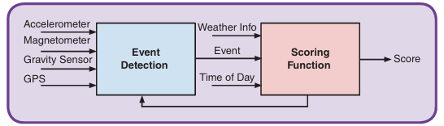

*Fig 1.4.1: Working of the SenseFleet system [**5**]*

* 1. **Advantages:**
     1. Flexibility: The device works regardless of positioning or orientation.
     2. Universality: Adaptable to different mobile devices and vehicle types.
     3. Integration: Utilises both GPS and motion sensors for comprehensive analysis.
     4. Calibration: Incorporates fuzzy sets for adaptability.
  2. **Limitations:**
     1. Lack of Standardisation: Standardisation, security measures, and reliance on GPS are areas to improve.

1. **Safe Drive System:**

The Safe Drive[6] methodology is based on smartphones' sensors and artificial intelligence algorithms to assess the driver's performance. In order to objectively assess driver behaviour, factors such as speed, acceleration, braking and lane restriction shall be considered. In order to promote safe driving practices, real-time feedback and incentives are provided, while contextual factors such as road conditions are used to assess fairness.

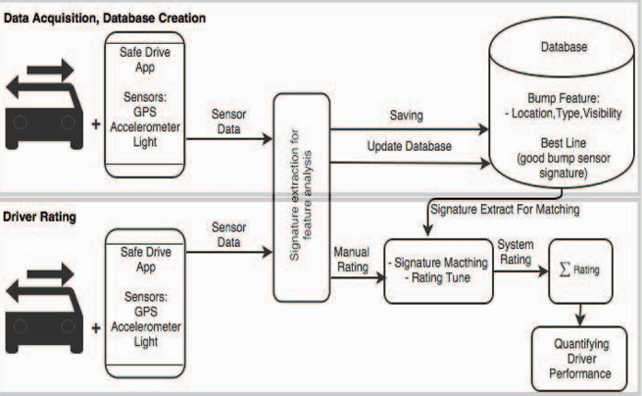

*Fig 1.4.2: Safe Drive System Methodology* **[**6]

* 1. **Advantage:**
     1. Objective Evaluation: The methodology utilizes smartphone sensors and machine learning algorithms to provide an objective evaluation of driving performance, eliminating subjective biases.
     2. Real-time Feedback: Drivers receive real-time feedback and incentives for safe driving practices, promoting immediate awareness and behavior modification.
  2. **Limitations:**
     1. Reliance on Smartphone Technology: The effectiveness of the methodology is contingent upon the availability and functionality of smartphones with compatible sensors, which may limit its applicability in regions with limited smartphone penetration.
     2. Data Privacy Concerns: Gathering driving data through smartphone sensors raises privacy concerns, as it involves collecting and analyzing personal information. Ensuring the privacy and security of drivers' data is crucial but may present challenges.

1. **Driving Behavior Analysis with OBD Data and Machine Learning:**
   1. **Data Source:**
      1. OBD Data: Leverages vehicle onboard diagnostics for rich performance data.
   2. **Implementation Technique:**

Using OBD data collected from vehicles to analyse driving behaviour. In order to find patterns and insights on aspects like acceleration, braking or fuel consumption, machine learning algorithms are used in this data. This approach provides a reliable method of understanding and enhancing driving behaviour through the combination of OBD data with advanced computer programming techniques.

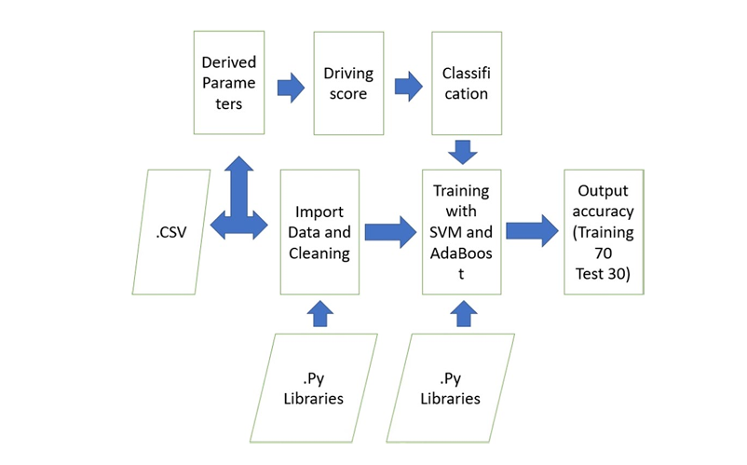

*Fig 1.4.3: Implementation technique [**7**]*

* 1. **Outcome:**
     1. Categorization: Identifies and classifies driving styles using machine learning.
     2. Applications: Useful for driver monitoring, insurance premium calculations, and promoting safer driving habits.
  2. **Limitations:**
     1. Standardisation: Acknowledges the need for standardised OBD data.
     2. Privacy Concerns: Recognizes potential privacy issues associated with data collection.

1. **General Insights:**
   1. Common Goal: All three methods aim to enhance driver behaviour analysis and contribute to safer driving habits.
   2. Diversity of Approaches: The solutions vary from smartphone-based systems to OBD data and machine learning, showcasing diverse strategies.

**1.5 Proposed Solution**

1. **Data acquisition using the AUTOSAR architecture and cloud integration Solutions:** 
   1. **AUTOSAR integration:** To enable efficient sensor data collection, the architecture of AutoSAR should be implemented and integrated in the current system. [8] [9] [10]
   2. **Cloud Integration:** To provide seamless transfer of collected data to cloud repositories via established cloud services or platforms, you can use existing cloud providers and platforms.[11]
   3. **Cloud Infrastructure:** In view of its scale, redundancy and accessibility, the establishment of a secure cloud based storage and processing infrastructure is necessary.
   4. **Data Validation:** Implement mechanisms to ensure the accuracy and completeness of the collected data during transmission to the cloud.
2. **Machine Learning Model Development for Data Categorization**

**Solutions:**

1. **Selection of models:** based on the nature of the data, select suitable machine learning algorithms such as neural networks, decision trees for efficient categorization.
2. **Training Dataset:** Curate a diverse and representative dataset for training the machine learning model to enhance its accuracy and generalization.
3. **Deployment strategy:** In order to ensure seamless integration of the data storage and retrieval system, a training model should be deployed on cloud.
4. **Continuous improvement:** In order to adapt to changing data patterns, introduce mechanisms for continuous model monitoring, evaluation and refinement.
5. **Ensuring Data Confidentiality and Integrity through Encryption**

**Solutions:**

1. **End-to-end encryption:** encrypt data from the point of collection to the point of transfer and storage using end-to-end encryption.[13][14]
2. **Secure key management:** In order to protect encryption keys and ensure a secure access to data, use robust key management practices. [15]
3. **Authentication mechanisms:** In order to verify the identity of users who access data, integrate robust authentication mechanisms. [16]
4. **Regular security checks:** to detect and address potential vulnerabilities in encryption and security measures, regular inspections shall be carried out.

**Overall Integration and Synergy:**

**1. System Integration:** Ensure seamless integration of data acquisition, machine learning, and encryption components within the overall system architecture.

**2. Interdisciplinary Collaboration:** Foster collaboration between data scientists, software engineers, and security experts to harmonize efforts in achieving the overarching goals.

**3. Scalability and Flexibility**: Design the system with scalability and flexibility in mind, accommodating future enhancements, increased data volumes, and evolving security requirements.

In summary, these refined solutions emphasize the practical actions needed to achieve efficient data acquisition, categorization, and security within a holistic system architecture. Regular monitoring, adaptation, and collaboration remain key elements for the success of this comprehensive solution.

**1.6 Gantt Chart**

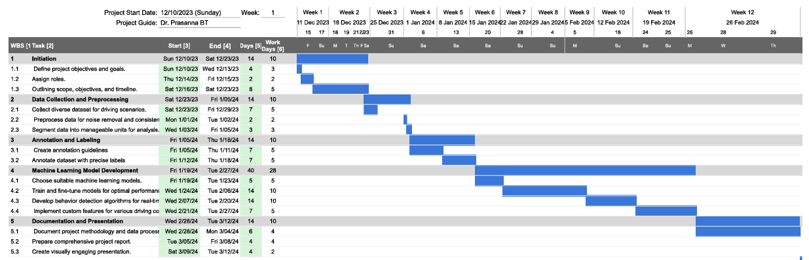

*Fig 1.6.1: Timeline of the project*

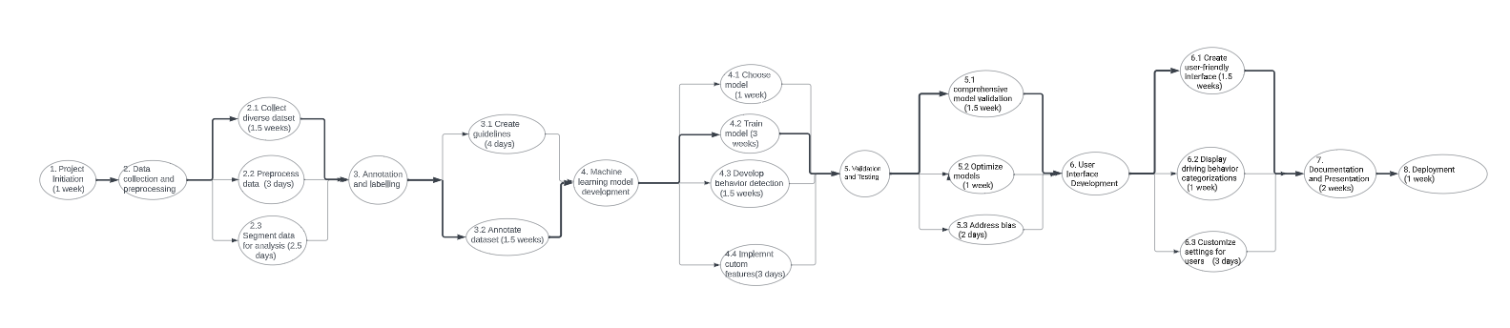

*Fig 1.6.2: Flowchart of the project implementation*

**Chapter 2: Literature Review with gap in the literature**

**2.1 Driving Style Recognition Using a Smartphone as a Sensor Platform**

**Authors: Derick A. Johnson and Mohan M. Trivedi**

**2011 14th International IEEE Conference**

The paper [4] investigates the utilisation of smartphone sensors for the recognition and categorization of driving styles. The authors propose a framework employing accelerometers and GPS sensors to collect and analyse driving behaviour data, subsequently applying machine learning techniques to classify styles such as aggressive, normal, and eco-friendly. The study establishes the feasibility of smartphones as effective sensor platforms for driving style recognition, showcasing potential applications in areas like insurance premium calculation and personalised driver feedback. However, the paper identifies several gaps and limitations, including variations in sensor quality across smartphone models affecting accuracy, privacy concerns regarding continuous data collection, and the omission of external factors like road conditions in driving style classification. The research calls for the development of real-time adaptive algorithms to enhance accuracy and responsiveness to changing driving conditions.

**2.2 Driver Behavior Profiling Using Smartphones: A Low-Cost Platform for Driver Monitoring**

**Authors: German Castignani, Thierry Derrmann, Raphaël Frank, and Thomas Enge**

**IEEE Intelligent transportation systems magazine Spring 2015**

The research paper [5] introduces the SenseFleet system as a smartphone-based solution for profiling and monitoring driver behaviour. Notable advantages of SenseFleet include its flexible device positioning, adaptability to various mobile devices and vehicles, and accurate detection of risky driving events. The system employs fuzzy sets during calibration, enabling it to adjust to different conditions. SenseFleet's simultaneous consideration of GPS and motion sensor data, along with the incorporation of weather conditions, contributes to a comprehensive view of driver behaviour. Despite these strengths, the paper identifies limitations, including the lack of standardisation, security measures, heavy reliance on GPS, and potential issues with reliability. The research underscores the drawbacks of telematics boxes, emphasising the cost-effectiveness and practicality of smartphone-based systems like SenseFleet for driver behaviour monitoring.

**2.3 A Fair and Effective Driver Rating System for Developing Region Authors: Munshi Yusuf Alam, Sunny Saurav, Ratna Mandal,Sujoy Saha, Subrata Nandi,Sandip Chakraborty**

**2017 9th International Conference on Communication Systems and Networks (COMSNETS)**

A critical need for an equitable and effective driver rating scheme tailored to developing regions is addressed in the paper [7]. The research presents a new solution for objectively evaluating driver performance, taking into account parameters such as speed, acceleration, braking and rear end behaviour, by integrating smartphones' sensors with machine intelligence. In regions with poor road infrastructure and challenging driving conditions, the system aims at providing valuable feedback to drivers as well as promoting safer driving choices and possibly reducing accident rates. In particular, the authors prioritise fairness, acknowledging the socioeconomic disparities in developing regions, and ensuring that the rating system is accessible to individuals with limited access to advanced technology or high end vehicles. While the paper proposes a viable solution for developing regions, there may be gaps in details relating to system realworld implementation, size and validation across different driver environments. In addition, a discussion of possible problems and limitations related to the proposed solution could be beneficial for this paper.

**2.4 Driving behaviour analysis and classification by vehicle OBD data using machine learning Authors: Raman Kumar, Anuj Jain**

**The Journal of Supercomputing 2023**

The paper [7] investigates the utilisation of On-Board Diagnostics (OBD) data from vehicles in tandem with machine learning techniques for the analysis and classification of driving behaviour. Leveraging OBD systems that capture comprehensive information about a vehicle's performance, the authors employ machine learning algorithms to categorise driving behaviour based on parameters such as speed, acceleration, braking, and engine data, aiming to identify various driving styles. The research demonstrates the potential of this approach in accurately categorising and analysing driving behaviour, offering applications in driver monitoring, insurance premium calculations, and feedback for safer driving habits. However, the paper acknowledges certain limitations, including the need for standardised OBD data across different vehicle models and potential privacy concerns associated with the collection and storage of this data. Additionally, the analysis may not fully consider external factors like road conditions and traffic. The identified gap in the paper lies in the need for a more in-depth discussion and exploration of strategies to address the highlighted limitations. Further elaboration on potential solutions or considerations for standardising OBD data, mitigating privacy concerns, and incorporating external factors into the analysis would enhance the practicality and applicability of the proposed approach in real-world scenarios. Additionally, insights into the scalability and robustness of the proposed method in diverse driving conditions could contribute to a more comprehensive understanding of its effectiveness.

**Chapter 3: System Requirements and Analysis**

1. **Hardware Requirements:**
   1. **In-Vehicle Sensor Systems:**
      1. High-resolution cameras for capturing road surface quality, weather conditions, and visibility.
      2. Accelerometers and gyroscopes for monitoring acceleration, braking, and steering.
      3. Physiological sensors (heart rate monitors, eye-tracking devices) for assessing driver physiological responses.
   2. **Onboard Data Processing Unit:**
      1. A powerful processing unit capable of real-time data analysis.
      2. Sufficient memory capacity for storing and processing large datasets.
   3. **Communication Module:**
      1. Wireless communication capabilities (e.g., 4G/5G) for real-time data transmission.
      2. GPS module for accurate location tracking.
2. **Software Requirements:**
   1. **Data Collection and Storage:**
      1. Data storage and management system for archiving sensor data.
      2. Database management software for efficient retrieval and analysis.
   2. **Machine Learning Algorithms:**
      1. Algorithms for pattern recognition and correlation between road conditions and driver behavior.
      2. Real-time analytics tools for immediate insights.
   3. **User Interface:**
      1. Intuitive dashboard for visualizing real-time and historical data.
      2. Customizable reports for in-depth analysis.
   4. **Integration with External Systems:**
      1. APIs for integration with governmental databases, weather services, and traffic management systems.
3. **Security and Privacy Measures:**
   1. **Data Encryption:**
      1. End-to-end encryption for data transmitted between the in-vehicle system and external servers.
4. **Testing and Calibration:**
   1. **Real-world Testing:**
      1. Comprehensive testing in diverse driving conditions to validate sensor accuracy and reliability.
   2. **Calibration Procedures:**
      1. Regular calibration protocols to maintain the precision of sensor measurements.

**Chapter 4: Tools and Technology Used**

1. **Hardware Tools:**
   1. **Smartphones:** 
      1. Multiple mobile phones, with a variety of sensors that can collect data.
      2. Ensure compatibility with the required sensors accelerometers, gyroscopes, GPS and the ability to run the necessary applications.
   2. **OBD-II Dongle:**
      1. A reliable OBD2 dongle to connect to OBD2 port of the vehicle.
      2. Ensure that the dongle is compatible with the appropriate protocols and gives you access to sensor data in your vehicle.
   3. **Cloud Storage:**
      1. For secure storage of collected data, cloud storage solutions are AWS S3, Google Cloud Storage and Azure Blob.
      2. To ensure the protection of confidential information, appropriate security measures should be implemented.
2. **Software Tools:** 
   1. **Data Collection App:** 
      1. To gather data from different sensors accelerometers, gyroscopes, GPS and send it to the cloud in a secure manner, build an application for smartphones.
      2. To create a user friendly interface for data collection and synchronization.
   2. **OBD II Data Retrieval Software**:
      1. Software to interact with OBD II dongle and retrieve data from the vehicle's sensors.
      2. Utilise libraries or APIs (e.gOBD-II Python library) to communicate with the dongle.
   3. **Machine Learning Libraries:**
      1. Python-based machine learning libraries (e.g., scikit-learn, TensorFlow, PyTorch) for building and training machine learning models on collected data.
      2. Use algorithms based on sensor data to classify driver behavior.
   4. **Database Management:** 
      1. A data management system for the cloud RDSe.g., AWS, Google Cloud SQL to organize and manage stored sensor information in an efficient way.
      2. To store both phone and car sensor data, you must set up the appropriate database schema.
      3. Backend Server: To handle data processing, model training, and communication between the mobile app and the cloud database, develop a backend server.
   5. **Flutter Framework:** 
      1. To create a cross platform mobile application for users to interact with the system, use the Flutter framework.
      2. Create an intuitive interface for users so that they can see their driving profiles, receive feedback and be able to find the information needed.
   6. **Authentication and authorisation tools:**
      1. In order to guarantee data privacy and user access control, establish secure authentication and authorisation mechanisms.
3. **APIs:** 
   1. To facilitate communication of mobile applications, back end servers and cloud databases, build API's.
4. **Security Measures:** 
   1. To ensure the secure transfer of data between mobile apps and cloud, implement encryption protocol.
   2. In order to protect user data and system integrity, use security best practices.

**Chapter 5: System Design**

**Proposed system design:**

The proposed system design aims to seamlessly integrate in-vehicle sensor data into a comprehensive framework for evaluating driving behaviour. The system takes inputs from sensors, collected through the AUTOSAR (Automotive Open System Architecture) interface, ensuring standardised communication between various electronic control units within the vehicle. This data is then transmitted to mobile devices, acting as intermediary hubs for real-time processing and storage. Leveraging the AUTOSAR interface ensures compatibility and interoperability across different vehicle components, enhancing the system's scalability and adaptability to diverse vehicle architectures.

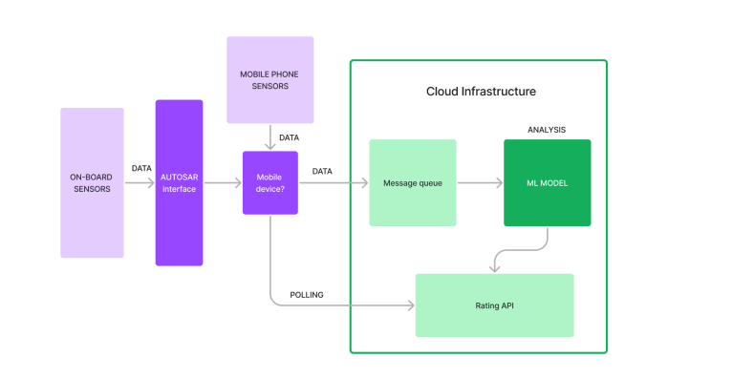

*Fig 5.1: Proposed System Design*

Upon reaching the mobile devices, the sensor data is channelled into a machine learning (ML) model designed to assess and analyse driving behaviour. The ML model, tailored for this specific purpose, incorporates algorithms that consider multiple parameters, including acceleration, braking, steering, and physiological responses from the driver. The model's architecture allows it to learn and adapt over time, continually improving its accuracy in evaluating driving habits.

The mobile devices serve a dual role, not only acting as data conduits but also as storage units, securely housing the collected sensor data. This ensures a centralised and organised repository, facilitating easy retrieval for future analysis or auditing purposes. Additionally, the mobile devices provide a user-friendly interface for drivers, displaying personalised feedback and insights derived from the ML model evaluation.

This system design prioritises the utilisation of standardised communication protocols, such as AUTOSAR, to establish a robust and efficient connection between in-vehicle sensors and the ML model. By leveraging mobile devices as intermediaries, the system enhances flexibility, allowing for real-time processing and storage, while the ML model contributes to a nuanced understanding of driving behaviour. This holistic approach holds the potential to revolutionise the assessment of driving habits, leading to informed interventions and ultimately contributing to enhanced road safety.

**Flutter app flow**

The Flutter app starts with a login page. If the account exists, it redirects to the dashboard; otherwise, it leads to the register page. After creating an account, it also redirects to the dashboard. On the dashboard, users can start a new trip, which redirects to a new trip page. Alternatively, they can access their previous trips or a help page. At the end of a trip, the results page displays the driver's score. During the trip, the app shows a speedometer and various radial gauges displaying segments of the current trip.

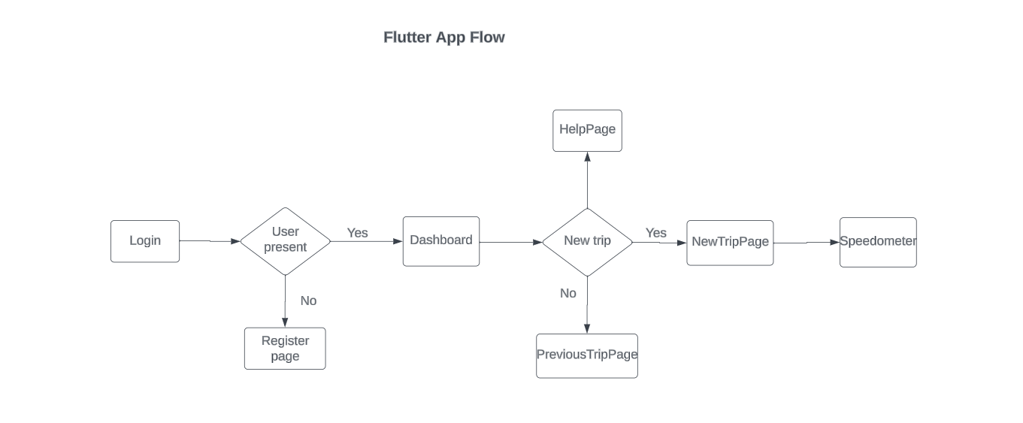

*Fig 5.2: Proposed Flutter App Flow*

**Proposed Implementation Methodology**

Collecting data from vehicle sensors, which include critical metrics such as acceleration, braking and turning, is the starting point of the proposed implementation methodology for this application. This data is transmitted securely to the Flutter mobile app in real-time, where it undergoes analysis. The relevant driving analysis data, including acceleration, braking and turn behaviour, shall then be transmitted to the API endpoint. Here, the data is stored in a dataset, organized efficiently for future analysis and model training. Using supervised learning methods, machine learning models are designed and tested in order to anticipate driving behaviour based on the data. In view of factors such as deviation from normal behavior and safety considerations, real time scoreboard algorithms are used to assign a score and percentile for each driver based on their behaviour. This score and percentage is displayed to the end user by Flutter app, enabling them to analyze their driving performance as well as encourage safer driving practice. In addition, the collected data will be stored to further analyse and refine models so as to continuously improve the driver analysis system.

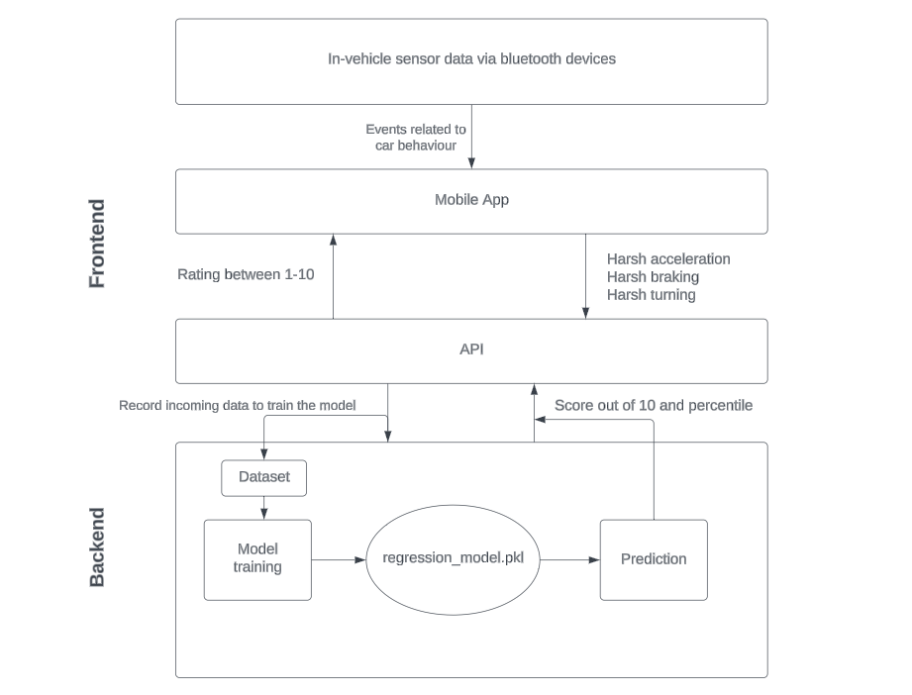

*Fig 5.3:Proposed Implementation Methodology*

**Chapter 6: System Implementation**

1. **Flutter App Implementation:**

The Flutter app serves as the user interface, providing a seamless interaction between drivers and the in-vehicle sensor data. Built with Dart programming language, the app ensures cross-platform compatibility and a responsive design. It offers real-time visualisations of driving behaviour insights, personalised feedback, and historical data analysis. The app integrates effortlessly with mobile devices, leveraging Flutter's rich widget library for an intuitive and engaging user experience.

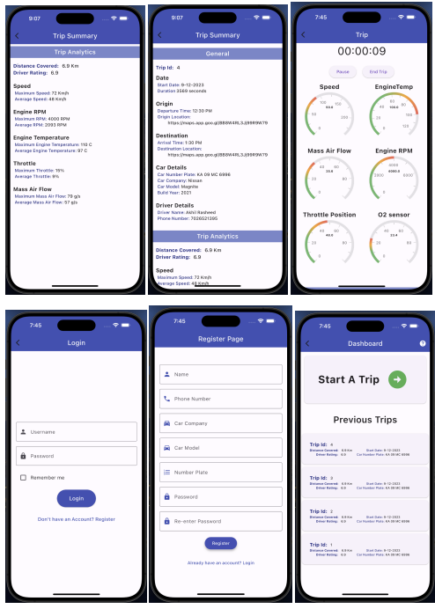

*Fig 6.1.1: Trip Summary Page*



*Fig 6.1.2: Trip Page Fig 6.1.3: Login Page*

*Fig 6.1.4: Register Page Fig 6.1.5: Dashboard*

1. **Dataset:**

The dataset provided by Pointer Telocation encompasses data collected from telocation devices installed in cars, primarily utilized for fleet management and Mobile Resource Management (MRM) purposes. The dataset spans from October 31, 2017, to November 18, 2017, comprising a total of 899,611 events. These events include both system-generated events and behavioral driver events, with a focus on capturing information related to driver behavior such as harsh turns, accelerations, and braking.

The dataset consists of information pertaining to 89 unique drivers, each identified by a unique DriverId. On average, each driver contributes approximately 10,108 events to the dataset. The data is structured with various attributes, including the type of event recorded, denoted by the EventName column, geographical coordinates of the event's occurrence (Latitude and Longitude), the speed of the vehicle (Speed km/h), and the timestamp of the event (ts).

For analysis purposes, two separate data frames are constructed: dfRaw encompasses all event types, while df specifically contains events relevant for behavioral analysis, such as harsh turns, accelerations, and braking events. This dataset offers a comprehensive insight into driver behavior and vehicle performance, facilitating in-depth analysis and insights for fleet management and MRM applications.

|  | **EventName** | **Latitude** | **Longitude** | **Speed km/h** | **ts** |
| --- | --- | --- | --- | --- | --- |
| **DriverId** |  |  |  |  |  |
| 0 | Timed Event | 34.1866 | -118.0881 | 64.0000 | 2017-11-01 00:00:02.430 |
| 0 | Distance Event | 34.1861 | -118.0892 | 53.0000 | 2017-11-01 00:00:05.600 |
| 0 | Distance Event | 34.1864 | -118.0896 | 34.0000 | 2017-11-01 00:00:13.640 |
| 0 | Distance Event | 34.1875 | -118.0889 | 33.0000 | 2017-11-01 00:00:26.070 |
| 0 | Distance Event | 34.1887 | -118.0865 | 32.0000 | 2017-11-01 00:00:35.090 |
| 0 | Distance Event | 34.1882 | -118.0873 | 47.0000 | 2017-11-01 00:00:46.330 |
| 0 | Distance Event | 34.1894 | -118.0864 | 24.0000 | 2017-11-01 00:00:55.320 |
| 0 | Timed Event | 34.1888 | -118.0861 | 35.0000 | 2017-11-01 00:01:02.770 |
| 0 | Distance Event | 34.1891 | -118.0851 | 43.0000 | 2017-11-01 00:01:06.610 |
| 0 | Distance Event | 34.1901 | -118.0839 | 48.0000 | 2017-11-01 00:01:14.530 |

*Table 6.2.1: Pointer Telelocation Dataset*

1. **Data understanding :**

Determine the distribution of events across drivers , plot the graph and observe the same. Also, observe what kind of events are present. Observe if looking at specific events change the distribution per driver in the dataset to realize the patterns.

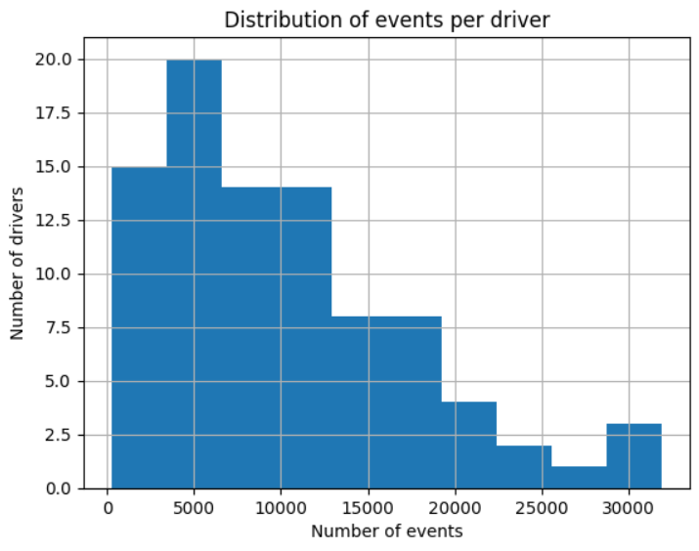

*Fig 6.3.1: Distribution of events per driver*

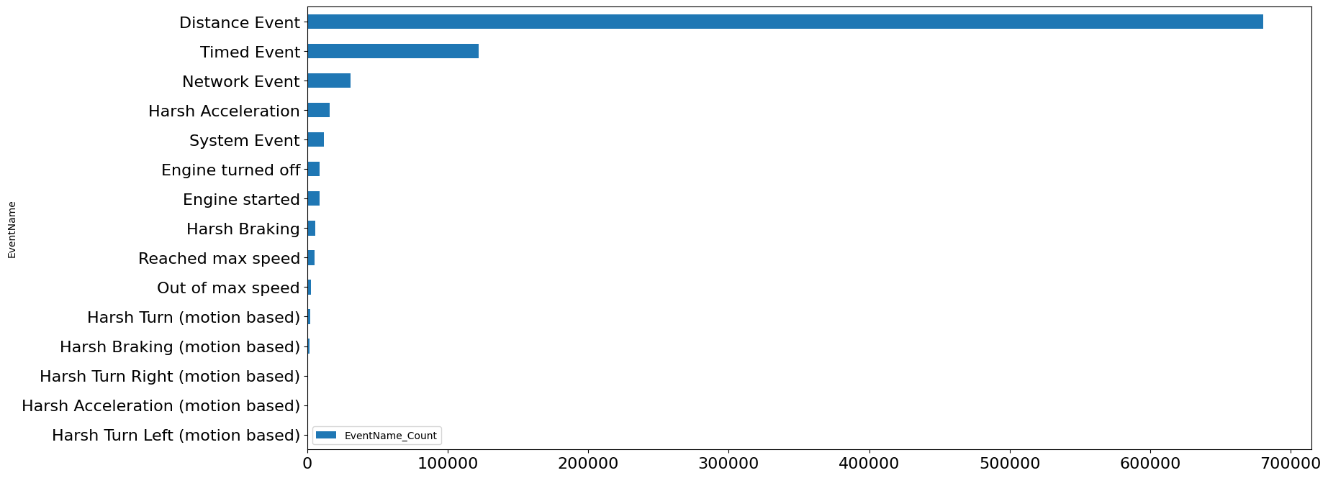

*Fig 6.3.2: Types of events*

After excluding Distance, Timed, and Network events, the dataset experiences a significant reduction in the number of events. Prior to removal, the dataset contained 899,611 events, while post-removal, this number diminishes to 54,242 events. This represents a reduction of approximately 0.94 events. Consequently, the current dataset consists of 54,242 events, which focuses more specifically on behavioral and system-generated events relevant for analysis.

1. **Data preparation**

The dataset underwent several refinements to focus solely on behavioral events and ensure data quality. Non-behavioral events were removed, resulting in a reduction of the dataset size. Additionally, drivers with insufficient samples were excluded to enhance the dataset's reliability. Further cleaning processes were performed to improve data consistency and accuracy. These refinements aimed to streamline the dataset, ensuring it comprises only relevant behavioral events from drivers with sufficient data points for robust analysis.

| **DriverId** |  | **EventName** | **Latitude** | **Longitude** | **Speed km/h** | **ts** |
| --- | --- | --- | --- | --- | --- | --- |
| 41 |  | Harsh Acceleration | 34.1899 | -118.0828 | 49.0000 | 2017-11-01 14:30:12.120 |
| 112 |  | Reached max speed | 34.1802 | -118.1362 | 115.000 | 2017-11-01 14:35:26.830 |
| 130 | \ | Out of max speed | 34.1689 | -118.1440 | 69.0000 | 2017-11-01 14:36:19.710 |
| 149 |  | Harsh Braking | 34.1591 | -118.1414 | 98.0000 | 2017-11-01 14:38:01.930 |
| 186 |  | Reached max speed | 34.1375 | -118.1473 | 122.000 | 2017-11-01 14:39:59.440 |

*Table 6.4.1: Refined Data*

1. **Feature Engineering:**

We establish a feature set by normalizing the number of events per type. For each behavioral event, we calculate the frequency of occurrences and divide it by the total drive distance. In the case of over-speeding, various metrics can be utilized, such as the total duration each driver exceeded the speed limit or a ratio between the current speed and the maximum allowed speed. These calculations enable us to standardize the representation of behavioral events across drivers and facilitate comparative analysis based on driving behavior metrics.Given the presence of two distinct system types (motion-based and non-motion-based), we will analyze each type separately rather than combining them. This approach ensures that the values and proportions remain comparable within each system type, avoiding potential inconsistencies. Furthermore, we will exclude the inaccurate over-speeding event, as previously identified, to maintain data integrity and reliability throughout the analysis process. By focusing on each system type individually and excluding problematic events, we can effectively assess driving behavior metrics and derive meaningful insights tailored to the characteristics of each system.

|  | **Harsh Acceleration** | **Harsh Braking** | **Harsh Turning** |
| --- | --- | --- | --- |
| **DriverId** |  |  |  |
| 0 | 0.0003 | 0.0122 | 0.0069 |
| 1 | 0.0002 | 0.0021 | 0.0000 |
| 2 | 0.0044 | 0.0120 | 0.0052 |
| 4 | 0.0000 | 0.0206 | 0.0369 |
| 5 | 0.0012 | 0.0049 | 0.0177 |

*Table 6.5.1: Normalized Behavioral Event Features*

1. **Understanding the correlation between features**

Generate a heat map on the cleaned data, after dealing with the outliers using the mean+k stds rule

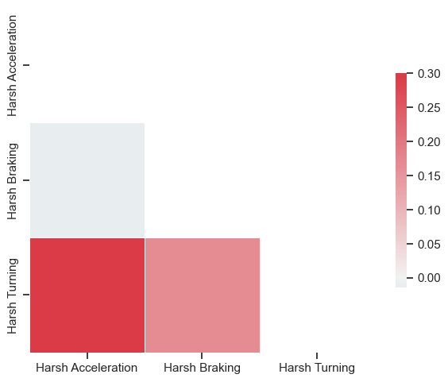

*Fig 6.6: Heatmap for the events*

1. **Building ML Model:**

In our analysis of the driving behavior data, we made the key assumption that the frequency of harsh events, such as harsh turns, accelerations, over-speeding, and braking, over a given distance, correlated with the likelihood of a driver being unsafe. We categorized drivers based on the occurrence of these events, with drivers experiencing zero harsh events being considered safe, while those with multiple harsh events were classified as unsafe.

To model this problem, we employed various approaches:

1. **Anomaly Detection and Clustering:** We explored the use of anomaly detection techniques or clustering algorithms to identify clusters of drivers exhibiting similar driving behaviors. By grouping drivers into clusters of safe and unsafe behavior, we aimed to distinguish patterns indicative of unsafe driving.
2. **Multivariate Metric:** We sought to develop a multivariate metric that captured our assumption across multiple dimensions. This metric allowed us to estimate the likelihood of unsafe driving by analyzing probabilities over the multivariate distribution of harsh driving events.
3. **Dimensionality Reduction:** We experimented with reducing the dimensionality of the data to a single unified metric. This approach involved aggregating multiple driving metrics into a single score or rank, simplifying the assessment of driver safety.
4. **Univariate Statistical Models:** We also considered modeling each type of driving event individually using statistical distributions. By analyzing the distribution of individual event types, we aimed to identify thresholds or patterns indicative of unsafe driving behavior.

Overall, our goal was to develop a robust modeling approach that effectively captured the relationship between driving behaviors and driver safety, enabling accurate identification of unsafe drivers. Each approach offered unique insights and trade-offs, contributing to a comprehensive understanding of driver behavior analysis.

**Chapter 7: System Testing and Result Analysis**

1. **ML Model testing**
2. **Model 1: Anomaly detection**

Anomaly detection was the first method we used. We tried to see if we could gather some meaningful anomalies that might point to information about driver safety. A number of approaches, including the HBOS and local outlier factor NLF were examined. The graph of the result is shown:

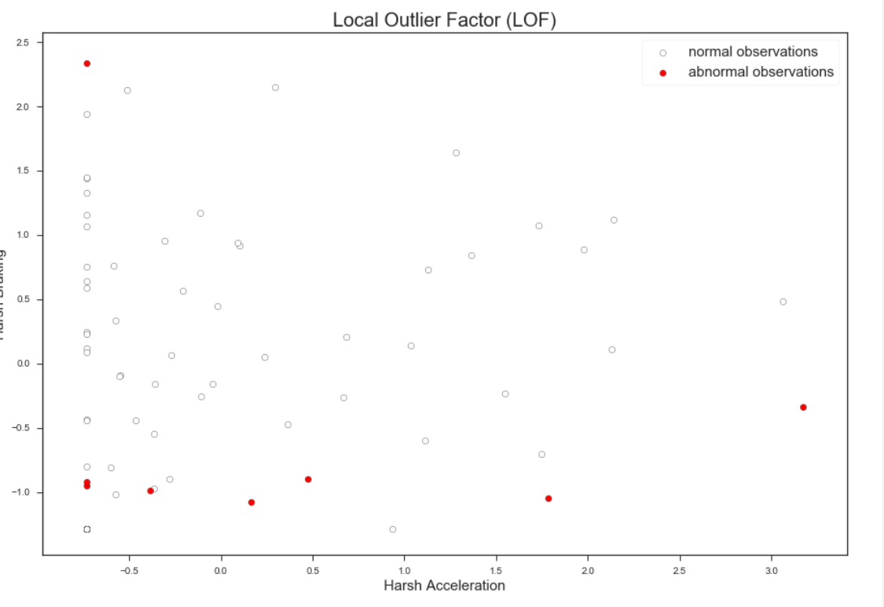

*Fig 7.1: LOF Model Graph Representation*

The LOF model looks for anomalous points in respect to each point's neighbourhood [17]. We've run LOF on all three dimensions, but the plot doesn't show the first two of them. We didn't get any meaningful results after playing with the model parameter number of neighbours. In this case, statistical outliers did not appear to be associated with behavioral differences.

1. **Model 2:Multivariate analysis**

The other approach was to identify a multivariate distribution of the drivers and then apply it for calculation of the probability that one driver would be at risk when compared with any large group of drivers. In essence, we're looking for drivers that are at the tail end of a multivariate right skewed distribution. As most of the methods assume a normal distribution, there are other assumptions missing or we don't have an effective implementation to work with, we didn't take this approach.

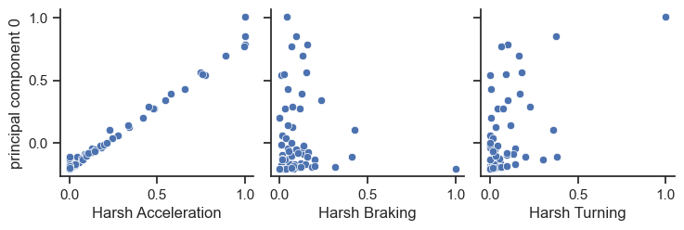

*Fig 7.2: Multivariate Analysis: correlation matrix of the original features and the first principal component*

The first principal component was the only one that preserved the order of the data (has positive correlation with all original features). However, it was not accurate enough to be used as a ranking factor given that this component explained only 70% of the variance.

1. **Model 3:Comparing each driver to a homogeneous population**

Finally, we decided to use a method of forecasting the distribution of events and then evaluating each individual vehicle by comparing them with general data from an overall homogeneous population. Since all events have a tilted distribution, we've made the decision to use an intersectional or gamma pattern. We used a weighted sum of probabilities in this approach, rather than using the multivariate model which might be difficult to explain. For each event distribution, we estimated the Cumulative Distribution Function (CDF) value and performed a weighted sum across all event types. It's a naive approach, since it ignores the interdependence of events, but it helps to make the model easy to explain.

1. **Estimating safety for an arbitrary subscriber**

The following process estimates the score of a new driver:

1. Calculate features - number of events per km

2. Calculate CDFs by estimating the CDF per feature value using the fitted functions during 'training'. We use the function's parameters to estimate the CDF per new value.

3. Calculate the weighted sum metric. The value of this metric corresponds to the point in the population this new driver resides in.

4. Calculate a rank within a population

|  | **Harsh Acceleration_CDF** | **Harsh Braking_CDF** | **Harsh Turning_CDF** | **metric** | **rank** |
| --- | --- | --- | --- | --- | --- |
| 32 | 0.0000 | 0.0000 | 0.0000 | 0.0000 | 0.0000 |
| 29 | 0.0000 | 0.0000 | 0.0000 | 0.0000 | 0.0000 |
| 70 | 0.0000 | 0.0000 | 0.0000 | 0.0000 | 0.0000 |
| 68 | 0.0000 | 0.0000 | 0.0000 | 0.0000 | 0.0000 |
| 67 | 0.0000 | 0.0000 | 0.0000 | 0.0000 | 0.0000 |
| 6 | 0.0000 | 0.0000 | 0.0000 | 0.0000 | 0.0000 |
| 27 | 0.0000 | 0.0000 | 0.0000 | 0.0000 | 0.0000 |
| 25 | 0.0000 | 0.0000 | 0.0000 | 0.0000 | 0.0000 |
| 51 | 0.0000 | 0.0000 | 0.0000 | 0.0000 | 0.0000 |
| 20 | 0.0000 | 0.0000 | 0.0000 | 0.0000 | 0.0000 |

*Table 7.1 : Top 10 safest drivers based on the metric*

|  | **Harsh Acceleration_CDF** | **Harsh Braking_CDF** | **Harsh Turning_CDF** | **metric** | **rank** |
| --- | --- | --- | --- | --- | --- |
| 39 | 0.0597 | 0.9814 | 0.8592 | 0.6334 | 0.8767 |
| 59 | 0.7542 | 0.4614 | 0.8925 | 0.7027 | 0.8904 |
| 44 | 0.9596 | 0.2901 | 1.0000 | 0.7499 | 0.9041 |
| 42 | 0.8186 | 0.8951 | 0.6245 | 0.7794 | 0.9178 |
| 72 | 0.8373 | 0.6875 | 0.8155 | 0.7801 | 0.9315 |
| 48 | 0.9596 | 0.7662 | 0.6328 | 0.7862 | 0.9452 |
| 7 | 0.9421 | 0.7009 | 0.7955 | 0.8128 | 0.9589 |
| 37 | 0.4886 | 0.9845 | 0.9724 | 0.8152 | 0.9726 |
| 16 | 0.9074 | 0.7545 | 0.8277 | 0.8299 | 0.9863 |
| 15 | 0.9596 | 0.5765 | 0.9756 | 0.8372 | 1.0000 |

*Table 7.2: Top 10 most risky drivers based on the metric*

1. **Results**:

There are two alternatives here for results: the metric (weighted sum), which gives a score with regards to the amount of events of each type, and the rank, which shows on which percentile of the population the driver is. Depending on the use case, one can decide on the right metric.

Since the relation between these two metrics is not 100% linear, we get different results than the training set. In this case we get a rank of 0.28 and metric of 0.15 for a driver with almost 0 events.

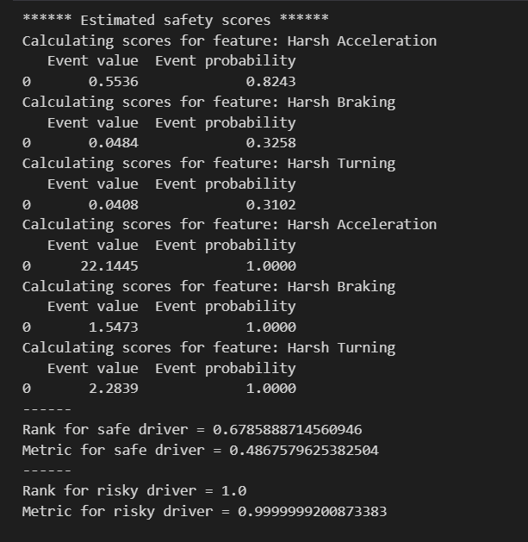

*Fig 7.3: Metric and percentile calculated*

**2. Flutter app testing:**

1. **Login Page Testing:**
2. Verify that the login page loads successfully.
3. Attempt login with valid credentials and ensure redirection to the dashboard.
4. Attempt login with invalid credentials and verify appropriate error message display.
5. **Registration Page Testing:**
6. Ensure the registration page loads properly.
7. Complete registration with valid details and verify redirection to the dashboard.
8. Attempt registration with existing email and validate error message display.
9. **Dashboard Testing:**
   1. Check if the dashboard loads correctly after login or registration.
   2. Verify the presence of options to start a new trip, access previous trips, and navigate to the help page.
10. **New Trip Page Testing:**
    1. Confirm that the new trip page loads successfully from the dashboard.
    2. Start a new trip and ensure proper functionality of the speedometer and radial gauges.
11. **Previous Trips Page Testing:**
    1. Navigate to the previous trips page from the dashboard and verify the display of past trip details.
12. **Help Page Testing:**
    1. Navigate to the help page from the dashboard and ensure relevant information is displayed.
13. **Results Page Testing:**
    1. After completing a trip, verify redirection to the results page and ensure accurate display of the driver's score.

**Chapter 8: Conclusion and Future Work**

**Conclusion:**

This project offers a comprehensive strategy for driver behaviour analysis and monitoring, utilising in-vehicle data recording systems that encompass CAN-bus and OBD interfaces, as well as other installed devices, to capture real-time data on vehicle performance and driver actions. In parallel, we harness smartphone-based sensing, using the sensors found in everyday smartphones, to assess driving behaviour in real time with dedicated data collection apps. Our efforts go beyond data collection, extending into behaviour detection methods. We utilise statistical and machine learning algorithms to continually evaluate and categorise driving behaviour, with a strong emphasis on preventing accidents and promoting safe driving practices. This approach can be tailored to monitor specific behaviours based on user or organisational preferences. In brief, this project integrates these approaches to create a comprehensive system for driver behaviour analysis and monitoring, with our primary goal being to enhance road safety, reduce accidents, and cultivate responsible driving habits, benefiting all road users.

**Future Work:**

1. **Real-time Intervention Systems:**

Explore the development of real-time intervention systems that can provide immediate feedback to drivers based on the ML model's analysis. Implement features like real-time alerts for risky behaviours or fatigue detection, fostering proactive safety measures.

1. **Predictive Analytics:**

Extend the ML model's capabilities to incorporate predictive analytics, aiming to anticipate potential hazards based on historical data. This could contribute to the development of predictive maintenance strategies for vehicles and early warnings for specific road conditions.

1. **Integration with Smart Cities:**

Collaborate with smart city initiatives to integrate the system into broader urban planning frameworks. Enable communication between the in-vehicle sensors and city infrastructure for improved traffic management, emergency response coordination, and enhanced overall road safety.

# **APPENDIX A - Project team details**

| **Project Title** | **Title of the project** | | |
| --- | --- | --- | --- |
| **USN** | **Team Members** | **Email ID** | **Mobile number** |
| 01JST20CS009 | Aditya Soundara Rajan | asounderajan3@gmail.com | 8618875858 |
| 01JST20CS014 | Akhil Rasheed | akhilrasheed16@gmail.com | 7026521395 |
| 01JST20CS119 | Prashasti Mattas | prmt5102@gmail.com | 7777053542 |
| 01JST20CS120 | Prithviraj B | prithviraj2062002@gmail.com | 7795316215 |

**PHOTO PHOTO PHOTO PHOTO**

Aditya Soundara Akhil RasheedPrashasti Mattas Prithviraj B  
Rajan

**APPENDIX B - COs, POs and PSOs**

**Mapping for the project work (20CS83P)**

**Course Outcomes:**

CO1: Formulate the problem definition, conduct literature review and apply requirements analysis.

CO2: Develop and implement algorithms for solving the problem formulated.

CO3: Comprehend, present and defend the results of exhaustive testing and explain the major findings.

**Program Outcomes:**

PO1: Apply knowledge of computing, mathematics, science, and foundational engineering concepts to solve the computer engineering problems.

PO2: Identify, formulate and analyze complex engineering problems.

PO3: Plan, implement and evaluate a computer-based system to meet desired societal needs such as economic, environmental, political, healthcare and safety within realistic constraints.

PO4: Incorporate research methods to design and conduct experiments to investigate real-time problems, to analyze, interpret and provide feasible conclusion.

PO5: Propose innovative ideas and solutions using modern tools.

PO6: Apply computing knowledge to assess societal, health, safety, legal and cultural issues and the consequent responsibilities relevant to professional engineering practice.

PO7: Analyze the local and global impact of computing on individuals and organizations for sustainable development.

PO8: Adopt ethical principles and uphold the responsibilities and norms of computer engineering practice.

PO9: Work effectively as an individual and as a member or leader in diverse teams and in multidisciplinary domains.

PO10: Effectively communicate and comprehend.

PO11: Demonstrate and apply engineering knowledge and management principles to manage projects in multidisciplinary environments.

PO12: Recognize contemporary issues and adapt to technological changes for lifelong learning.

**Program Specific Outcomes:**

PSO1: Problem Solving Skills: Ability to apply standard practices and mathematical methodologies to solve computational tasks, model real world problems in the areas of database systems, system software, web technologies and Networking solutions with an appropriate knowledge of Data structures and Algorithms.

PSO2: Knowledge of Computer Systems: An understanding of the structure and working of the computer systems with performance study of various computing architectures.

PSO3: Successful Career and Entrepreneurship: The ability to get acquaintance with the state-of-the-art software technologies leading to entrepreneurship and higher studies.

PSO4: Computing and Research Ability: Ability to use knowledge in various domains to identify research gaps and to provide solution to new ideas leading to innovations.

**Justification for CO-PO and PSO mapping**

The motivation of this project stemmed from the need to address the rising concerns surrounding road safety and driver behavior. By leveraging computing knowledge and foundational engineering concepts, we formulated the problem definition and conducted a thorough literature review to understand existing solutions and requirements. The project aimed to develop and implement algorithms for analyzing driver behavior using smartphone sensors, aligning with CO1 and CO2. Through exhaustive testing and analysis, we comprehended, presented, and defended the results, explaining major findings to stakeholders, thus fulfilling CO3. Our work also contributed to various program outcomes and program specific outcomes. For instance, by building a computer-based system for driver behavior analysis, we addressed societal needs related to safety and transportation, meeting PO3. We applied research methods to design experiments, analyze data, and provide feasible conclusions, reflecting PO4. Additionally, the project allowed us to propose innovative solutions using modern tools, demonstrating PO5. Throughout the project, we assessed societal, health, and legal issues related to driver behavior profiling, adhering to ethical principles and professional responsibilities, as outlined in PO6 and PO8. Collaboration within the team, effective communication, and project management skills were essential for success, showcasing PO9, PO10, and PO11. Lastly, the project enhanced our problem-solving skills by applying standard practices and algorithms to model real-world problems, aligning with PSO1. The development of a smartphone-based system provided insights into computer systems' structure and working, contributing to PSO2. Moreover, the project paved the way for potential entrepreneurship opportunities in the domain of road safety technology, fulfilling PSO3. Lastly, our research and development efforts contributed to computing and research abilities, enabling us to identify research gaps and propose innovative solutions, thus aligning with PSO4.

| **Table of Mapping of CO, PO and PSO:** | | | | | | | | | | | | | | | | | | |
| --- | --- | --- | --- | --- | --- | --- | --- | --- | --- | --- | --- | --- | --- | --- | --- | --- | --- | --- |
| **SUBJECT** | **CODE** | **CO** | **PO1** | **PO2** | **PO3** | **PO4** | **PO5** | **PO6** | **PO7** | **PO8** | **PO9** | **PO10** | **PO11** | **PO12** | **PSO1** | **PSO2** | **PSO3** | **PSO4** |
| **Project Work** | **20CS83P** | **CO1** |  |  |  |  |  |  |  |  |  |  |  |  |  |  |  |  |
| **CO2** |  |  |  |  |  |  |  |  |  |  |  |  |  |  |  |  |
| **CO3** |  |  |  |  |  |  |  |  |  |  |  |  |  |  |  |  |

**Note:**

**Scale**

**0. –.Not Applicable**

**1 – Low relevance Scale**

**2 – Medium relevance Scale**

**3 – High relevance Scale**

**References**

# Ministry of Road, transports, and highways report for the year 2021

[<https://morth.nic.in/sites/default/files/RA_2021_Compressed.pdf>]

# Ziebinski, A.; Cupek, R.; Grzechca, D.; Chruszczyk, L. Review of Advanced Driver Assistance Systems (ADAS). In AIP Conference Proceedings; AIP Publishing LLC: Melville, NY, USA, 2017; p. 120002. [[CrossRef](https://pubs.aip.org/aip/acp/article-abstract/1906/1/120002/681133/Review-of-advanced-driver-assistance-systems-ADAS?redirectedFrom=fulltext)]

# An overview of sensors in Autonomous Vehicles [<https://www.sciencedirect.com/science/article/pii/S1877050921025540> ]

# Driving Style Recognition Using a Smartphone as a Sensor Platform, Authors: Derick A. Johnson and Mohan M. Trivedi, 2011 14th International IEEE Conference

[<https://ieeexplore.ieee.org/abstract/document/6083078>]

# Driver Behavior Profiling Using Smartphones: A Low-Cost Platform for Driver Monitoring, Authors: German Castignani, Thierry Derrmann, Raphaël Frank, and Thomas Enge, IEEE Intelligent transportation systems magazine Spring 2015

[<https://ieeexplore.ieee.org/abstract/document/7014406>]

# A Fair and Effective Driver Rating System for Developing Region, Authors: Munshi Yusuf Alam, Sunny Saurav, Ratna Mandal,Sujoy Saha, Subrata Nandi,Sandip Chakraborty, 2017 9th International Conference on Communication Systems and Networks (COMSNETS) [<https://ieeexplore.ieee.org/abstract/document/7945432>]

# Driving behavior analysis and classification by vehicle OBD data using machine learning, Authors: Raman Kumar, Anuj Jain, The Journal of Supercomputing 2023 [https://link.springer.com/article/10.1007/s11227-023-05364-3#:~:text=Key%20driving%20e vents%2C%20such%20as,are%20considered%20in%20the%20model]

# Research and Application of Three Protocols Based on AUTOSAR [<https://ieeexplore.ieee.org/document/10073432> ]

# Explanation of Adaptive Platform Software Architecture [<https://www.autosar.org/fileadmin/standards/R21-11/AP/AUTOSAR_EXP_SWArchitecture.pdf> ]

# Basic Concepts on AUTOSAR Development [<https://ieeexplore.ieee.org/document/5522844> ]

# Cloud Integration [<https://www.techtarget.com/searchcloudcomputing/definition/cloud-integration> ]

# Driver behavior profiling: An investigation with different smartphone sensors and machine learning [<https://journals.plos.org/plosone/article?id=10.1371/journal.pone.0174959> ]

# The Many Faces of End-to-End Encryption andTheir Security Analysis [<https://www.researchgate.net/publication/319633280_The_Many_Faces_of_End-to-End_Encryption_and_Their_Security_Analysis> ]

# End-to-End Encryption Techniques Kartik Giri1, Namit Saxena2, Yash Srivastava3, Pranshu Saxena4 1-4Department of Computer Science and Engineering, Inderprastha Engineering College, Ghaziabad, India [<https://www.irjet.net/archives/V7/i6/IRJET-V7I6202.pdf> ]

# Secure Key Management in the Cloud [<https://link.springer.com/chapter/10.1007/978-3-642-45239-0_16> ]

# A Review Of Authentication Methods [<https://www.researchgate.net/publication/311514269_A_Review_Of_Authentication_Methods> ]

# LOF model [<https://scikit-learn.org/stable/auto_examples/neighbors/plot_lof_outlier_detection.html> ]